

# OTT-Over the Top

*Areek Rizvi, Ayush Verma, Irfan Ahmad Khan, Nemali Venkata Subba Reddy,*

*under the humble guidance of Dr. Sudhanshu Prakash Tiwari School of Computer Science and Engineering Lovely Professional University, Punjab, India*

*‘*

# Abstract—OTT (over-the-top) may be a means of providing television and film content over the net at the request and to suit the wants of the individual consumer. The term itself stands for “over-the-top”, which suggests that a content provider goes over the highest of existing internet services. With OTT video delivery technology, people now have many options at their fingertips. they need the power to look at content on a range of platforms such as Smart TVs, Roku, computers, tablets, mobile phones, or gaming consoles. They even have the choice to access multiple distributors for specialized programs and examine channels by “app switching”, giving them more control over the content they favor to purchase and watch.

1. **Introduction**

Traditionally, the use of movies and other audio and video content has been relatively stableon social media such as theater and television. As technology advanced, it became more accessible at home and whenever necessary with the introduction of VHS, DVDs, Blu-rays and disk rental services. In addition, cable television delivers content via Co-axial cables and fiber optic cables. Something better, the service emerged as a Direct-to-home (DTH) technology with satellite and vessel communications deliver the highest quality streaming and content required directly to the consumer. Recently advances in technology have made movie or TV watching much easier online Streaming or Video on Demand (VoD) services VoD refers to the streaming of video content over Internet, through applications commonly referred to as Over-The-Top (OTT). Viewers can access the video content via OTT applications on any connected device such as smartphone, smart TV, tablet, desktop computer, laptops, etc. Unlike traditional media, broadcast media tells a variety of non-existent stories restricted censors, box office or demographics. It offers a highly advanced viewing experience audio and visual quality, as long as consumers have a stable internet.

OTT bypasses cable, broadcast, satellite television and other platforms that generally act as a controller or distributor and enables disintermediation. The sole gateway to consumers’, in the age of traditional media, was through film distributors, theatre runners, television networks or Multiple System Operators (MSOs). With OTT, the content creators can interact with their audience directly through a web page or Smartphone app. This offers the comfort of viewing movie and other entertainment at one’s convenient time and place. Once considered a luxury, an increasingly growing number of Indians are shifting towards cord-cutting or online streaming. While the figures show that the VoD industry is still at its nascent stage, the entry of almost 40 VoD companies in a span of just three years indicates the massive potential of the industry. Out of five Smartphone owners in India, at least four people watch content in at least one OTT app.

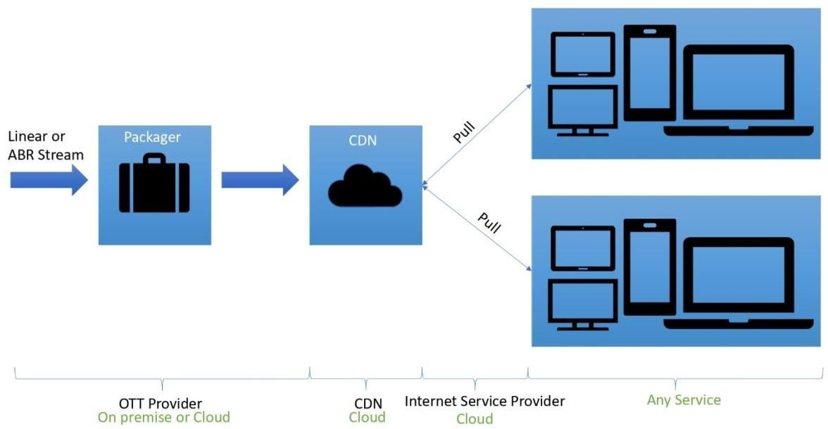

# Literature Review/Survey

* **The global development of OTT**

The global development of OTT The evolution from digital viewing into online viewing had everything to try and do with the breakthrough of computer technologies. OTT bypasses cable, broadcast, satellite TV, and other platforms that generally act as a controller or distributor and enables disintermediation. The evolution from digital viewing to online viewing had everything to try and do with the breakthrough of computer technologies. during this phase, the net was used mainly to drive viewers to observe the TV programs the standard way. Eventually, the web became another major battlefield for full streaming of TV and online programs.

# Viewing behaviour on mobile devices

The most recent innovation that has tremendously affected the event of OTT is mobile viewing. The emergence of mobile devices like smartphones, tablets, and Ultrabooks has inexorably challenged the boundary between new media and traditional television, reshaping the ways within which programs are both produced, and viewers watch them. This ground-breaking age has prompted global academics to seek out those factors whereby the audience is inclined to decide on one medium over another, additionally because of the relationships among media types.

# Working of OTT

Here is how OTT technology looks in action:

* Broadcasters upload video content to an OTT video hosting platform
* The video host transmits the info to remote servers via a content delivery network (CDN)
* Viewers select the content they require to stream on the user-facing video gallery
* The video player on the device pulls the video content from the CDN’s server with the net

# Issues with OTT

1. Misunderstanding your audience

Misunderstanding your audience, You need to understand who goes to be watching and what they may want to look at. this can be important when it involves niche channels

# Using the wrong technology

Using the incorrect technology There is a right way and a wrong thanks to do all this from a technology standpoint nowadays. the proper way is to leverage the ability of the cloud.

There is a right way and a wrong way to do all this from a technology standpoint nowadays. The right way is to leverage the power of the cloud.

# Showing the wrong content

Showing the incorrect content This is part of the primary two points ― giving your audience what they need to look at and by using TV business analytics. Big Data, because it accustomed be called the industry much prefers the term ‘analytics’ now provides invaluable insights into what parts of your content library are working and what parts don't seem to be

# Offering a poor user experience

Offering a poor user experience One of the problems operators face in launching a brand-new OTT service is that the competition is, essentially, the massive global SVOD players - Netflix, Disney+, Amazon Prime Video etc. These have developed their user experience carefully to be an ultra-efficient means of connecting customers with content swiftly, employing personal recommendations, exemplary programme design, and seamless support across multiple platforms.

# Catching a bad wave

Catching a foul wave Anyone who’s surfed within the ocean, or maybe thought of surfing, will understand that not all waves pick you up and carry you to the beach; some fade to nada around you leaving you paddling in open water. And this can be bushed constant flux. As with anything, there are tides and there are trends. Services aimed toward the 3D market and therefore the VR market have failed, ones that have checked out esports have grown rapidly. Trying to second guess which way the OTT market will develop is extremely very like playing the stock market; the rewards are potentially great, then again so are the risks. Managing expectations

# 5G technology impact the OTT services

In future 5G technology will allow faster data rates, which is able to completely change scenario of how we consume content. The 5G technology will enable users to download a full HD movie in but 10 seconds which is way better than 10 min on the present 4G network. this latency speed on 4G network is around 3040 milliseconds, but with the assistance of 5G technology this delay is chopped to about 1 millisecond or even less.

The recommended download speeds are broken down as follows:

* + 25 Mbps: sufficient for streaming 1080p HD video
  + 10 Mbps: sufficient for 720pvideo
  + 5 Mbps: sufficient for 480pvideo

# Market share of OTT platforms in India

|  |  |
| --- | --- |
| OTT  Platforms | Usage Share (in  %) |
| Hotstar | **20** |

|  |  |
| --- | --- |
| Amazon Prime  Video | **20** |
| Netflix | **15** |
| SonyLiv | **5** |
| Zee5 | **5** |
| ALTBalaji | **5** |
| Voot | **5** |
| Hungama  Play | **5** |
| Eros Now | **5** |
| Others | **15** |

1. **Research Methodology**

Video hosting platforms include a large style of tools for hosting, storing, and managing video content at many alternative price points. Some hosting features that are valuable for creating an [OTT](https://www.dacast.com/blog/5-business-ott-platforms-for-over-the-top-video-content/) [platform i](https://www.dacast.com/blog/5-business-ott-platforms-for-over-the-top-video-content/)nclude [HTML5 video players,](https://www.dacast.com/html5-video-player/) white-label capabilities, brand customization, and API access. some of the most innovative OTT platform technology is available via Dacast, Vimeo OTT, and [Brightcove.](https://www.dacast.com/blog/brightcove-competitors-comparison-dacast-and-ooyala/)

# Technology in OTT

For starters, all content across OTT platforms is stored within the cloud. The cloud is formed of many physical data centres spread across the planet, rife with cables connecting heavy-duty equipment. These are founded by major tech giants like Google, Amazon and Microsoft and are widely called Google Cloud Platform, Amazon Webservices and AZURE, respectively.

# Storage for OTT

OTT players rent space within the cloud for storing their files. On AWS, as an example, the fundamental monthly fee for storing 1,000 GB of content per hour is $125. the speed changes looking on several factors, including the region of cloud storage.

# Encryption of Data

Every time a streaming platform creates or acquires content, it uses a third-party encoding software to compress the first file which will run in terabytes (TBs) into a streaming- friendly lower file size.

# Content Delivery Network

Content delivery network (CDN) is precisely what it sounds like: a network of servers that delivers content. Most online video platforms partner with professional CDNs, so this isn’t typically the most concern for broadcasters. You’ll want to form sure that

your chosen video hosting platform uses a CDN that has servers stationed round the globe. this can help maintain the standard of your stream for viewers in every corner of the world. it'll also help avoid lagging and buffering. However, if you're self- hosting, you may have to choose a CDN of your own. thanks to complicated CDN pricing structures, this may get expensive and confusing, so choosing a video hosting platform with a built-in CDN is that the thanks to go.

# Video Licensing

Video licensing is strictly what it looks like — it’s the legal process of paying to license video content for the other project. Copyright laws (and the overall concept of intellectual property) exist to shield creatives. So, licensing videos works rather like finding images, fonts, music, or sound effects. If you're using something that somebody else created, you’ll must license it. Video licensing is simply the method of filling out and paying for a license, usually from a stock video website or maybe a content creator’s online marketplace.

# DRM

DRM stands for “Digital Rights Management”. It’s a technology that in effect pairs a digital eBook to the device that it’s downloaded to. This prevents the file from being shared with someone who didn’t purchase their own copy, because the DRM on the shared file won’t match with the device the opposite person is using. The result's a file that's useful only to the first purchaser when it’s run on a licensed device.

Figure 2 shows how operations are carried.

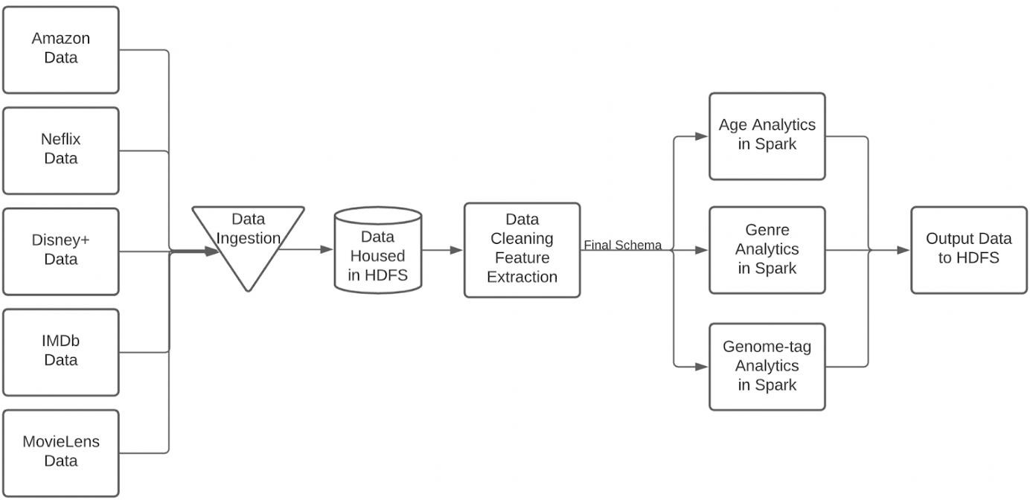

Fig 2

# Conclusion

This OTT platform is made by using React.js, Node.js, and various front-end and Back-end languages. It shows how the website works and how action is performed. Which kind of operations are going to performed based on user input.

# Results Snapshots:

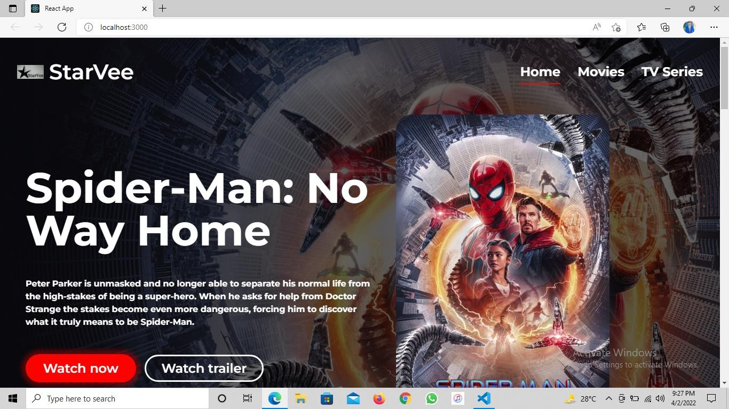

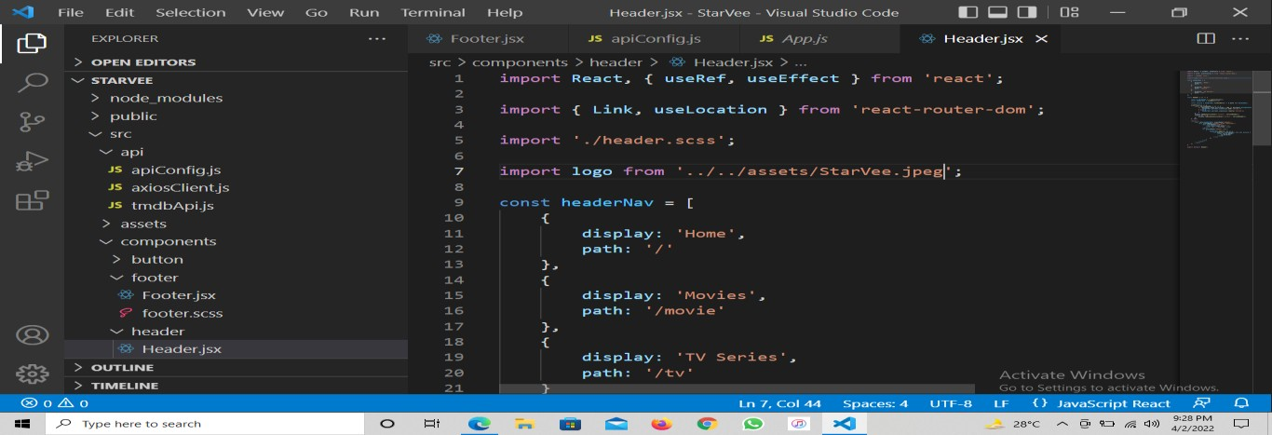

GitHub code an report link

https://github.com/ayushx16/Starve/

Project Link

https://starvee.herokuapp.com/

1. **References**

* Albarran, A. B. (2013). Media management and economics research in a transmedia environment. New York: Routledge. Ashrafi, D. (2014).
* Forcing the connection: The antitrust concerns with broadband data caps and data discrimination in the wake of the new Internet television age. Santa Clara Law Review, 54,

465. Banerjee, A., Alleman, J., & Rappaport, P. (2013).

* Video-viewing behaviour in the era of connected devices. Communications & Strategies, (92), 19. Bury, R. (2005). Cyberspaces of their own: Female fandoms online (Vol. 25). New York: Peter Lang. Bury, R., & Li, J. (2013).
* Is it live or is it timeshifted, streamed or downloaded? Watching television in the era of multiple screens. New Media & Society, 6(0), 119. Dimmick, J., & Rothenbuhler, E. (1984). The theory of the niche: Quantifying competition among media industries.
* Journal of Communication, 34(1), 103-119. Dimmick, J., Chen, Y., & Li, Z. (2004). Competition between the Internet and traditional news media: The gratification-opportunities niche dimension. The Journal of Media Economics, 17(1), 19-33.
* Dimmick, J., Feaster, J. C., & Hoplamazian, G. J. (2010). News in the interstices: The niches of mobile media in space and time. New Media & Society, 13(1), 23-39.
* Ferguson, D. A., & Perse, E. M. (2000). The World Wide Web as a functional alternative to television. Journal of Broadcasting & Electronic Media, 44(2), 155-174. Ferguson, D. A., Greer, C. F., & Reardon, M. E. (2007). Uses and gratifications of
* MP3 players by college students: Are iPods more popular than radio? Journal of Radio Studies, 14(2), 102-121. Ghadialy, Z. (2011). “Mobile TV technologies.” Retrieved April 2016, from Elert, N., Henrekson, M., Wernberg, J. (2016), Two sides to the evasion: The pirate bay and the interdependencies of evasive entrepreneurship.
* Journal of Entrepreneurship and Public Policy, 5(2), 176-200. Falch, M., Tadayoni, R. (2014), Regulation of international roaming data services within the EU. International Economics and Economic Policy, 11(1-2), 81-95. FCC. (2015), Report and Order on Remand, Declaratory Ruling, and Order, FCC No. 15-24. Gasparini, J. (2014),
* The Journal of the Korea Contents Association, 14(8), 342-364.